http://images2.americanprogress.org/CAPAF/c4logos/HalfinTen_small.jpg

http://halfinten.org/uploads/support_files/hit_footer_small.png

**Take Action and #TalkPoverty National Toolkit:**

***50th Anniversary of the War on Poverty***

January 8th marks the 50th anniversary of President Lyndon B. Johnson’s State of the Union address calling on the nation to launch an “unconditional war on poverty.” This address signaled a renewed national commitment to fighting poverty through targeted policy resulting in programs like Medicare, Medicaid, Head Start, Pell Grants, expansions to Social Security and nutrition assistance.

In early January, the media will be asking one simple question: **we launched a war on poverty. How are we doing?**  Many will use this opportunity to attack the safety net and argue for even deeper cuts to the programs that families rely on in an economy that still fails them. It’s critical that we use this opportunity to push back on false claims and narratives, and put forward a proactive vision about how to cut poverty over the next 50 years.

The bottom line is: the poverty rate [fell from 26% in 1967 to 16% in 2012](http://socialwork.columbia.edu/sites/default/files/file_manager/pdfs/News/Anchored%20SPM.December7.pdf) when the safety net is taken into account. **The War on Poverty hasn’t failed; our economy has failed**. Instead of focusing their attention on rebuilding an economy that works for everyone, too many policymakers are still focused on reckless cuts to safety net programs that are working overtime to make up for an economy that isn’t meeting most Americans’ basic needs. [1.3 million Americans](http://www.cbpp.org/cms/index.cfm?fa=view&id=4060) just lost emergency unemployment benefits, and Congress is still debating how much to cut nutrition assistance instead of how to help put food on the table [even after a significant cut in November.](http://www.cbpp.org/cms/index.cfm?fa=view&id=4036) **It’s time to reset the whole debate and recommit to cutting poverty**.

**Take action, share your story, and get your elected officials to listen.** This toolkit provides several resources to help you take action with the media, other advocates, and your elected officials around the 50th anniversary of the War on Poverty including:

* Important state-by-state and national data from Half in Ten and its partners
* Media talking points
* Questions and answers about the War on Poverty
* Sample op-ed, press release, and letter to the editor
* Ways to take action online by joining the #TalkPoverty digital movement including infographics and sample social media
* Ways to tell your story through Our American Story and get your voice in the media
* New reports from the Center for American Progress and Half in Ten campaign

**Need further assistance? We’re here to help! Contact:** Erik Stegman, Manager, [Half in Ten Campaign](http://www.halfinten.org)**,** [estegman@americanprogress.org](mailto:estegman@americanprogress.org), 202-481-8145

**Explore Poverty Data in Your State**

*The following resources are intended to help you develop advocacy materials to raise your voice in your local community with the media, policymakers and other advocates. We encourage you to incorporate this data into your op-eds, handouts, meetings with editorial boards, meetings with policymakers and other public education efforts.*

**Half in Ten State of the States 2013 Report**

Half in Ten also publishes an annual report analyzing all of the above indicators comparing where each state ranks. [“Resetting the Poverty Debate: State of the States 2013”](http://halfinten.org/blog/news/resetting-the-poverty-debate-state-of-the-states-2013/) also includes 51 state-by-state fact sheets and tables with data for each indicator from all 50 states and the District of Columbia.

**Half in Ten Education Fund State Data Website**

Our partner, the Half in Ten Education Fund, maintains an [interactive website](http://halfinteneducation.org/poverty-indicators/) where you can find state-by-state data and information on the following indicators of economic security and opportunity:

To explore [data by state](http://halfinteneducation.org/poverty-indicators/), including your state fact sheet and congressional district data, [click here](http://halfinteneducation.org/poverty-indicators/).

To explore data by indicator and see where all the states rank, click on the following:

* [Poverty rate](http://halfinteneducation.org/states-indicator/?id=3)
* [Child poverty rate](http://www.americanprogressaction.org/wp-content/uploads/2013/12/HiT-States-report-4.pdf#page=9&zoom=auto,0,712)
* [Unemployment rate](http://halfinteneducation.org/states-indicator/?id=7)
* [Hunger and food insecurity](http://halfinteneducation.org/states-indicator/?id=13)
* [Affordable housing](http://halfinteneducation.org/states-indicator/?id=15)
* [Assets and savings](http://halfinteneducation.org/states-indicator/?id=16)
* [High school graduation](http://halfinteneducation.org/states-indicator/?id=4)
* [Disconnected youth](http://halfinteneducation.org/states-indicator/?id=5)
* [Higher education attainment](http://halfinteneducation.org/states-indicator/?id=6)
* [Gender wage gap](http://halfinteneducation.org/states-indicator/?id=8)
* [Unemployment insurance coverage](http://halfinteneducation.org/states-indicator/?id=14)
* [Children living apart from parents (foster care)](http://halfinteneducation.org/states-indicator/?id=9)
* [Teen birth rate](http://halfinteneducation.org/states-indicator/?id=10)
* [Health insurance coverage](http://halfinteneducation.org/states-indicator/?id=11)

**Talking Points for Media**

* **The War on Poverty hasn’t failed; our economy has failed**. The War on Poverty put in place an essential social safety net that has helped keep millions of people out of poverty. This safety net goes back to early 20th century and includes vital programs like Social Security, Medicare, Medicaid, and federal support for education. But there’s much more to do to successfully keep people out of poverty and help them move into the middle class.
* **The real challenge today is that there aren’t enough good paying jobs for families to live on and the cost of housing, child care, and other basic needs is far too high.** Those at the very top of the income ladder seem to be only ones benefitting from economic growth. With unemployment high and wages down, too many lower- and middle-income Americans are still living in the recession. As inequality and outsize income gains at the top continue to rise, most of new jobs created in this country pay very low wages. Consequently, 46.5 million Americans live in poverty and 1 in 3 Americans teeter on its brink because our economy isn’t working for them.
* **Our safety net is working overtime to make up for the failed economy**. When families fall on tough times due to job loss, unexpected medical costs and other challenges, programs like unemployment insurance, Medicaid, nutrition, housing, and child care assistance keep families on their feet. A recent Columbia University study shows that without these programs, many of which have their roots in the War on Poverty, our poverty rate would be nearly double today.
* **Poverty doesn’t just go away. It’s something we must constantly work to reduce. And we shouldn’t give in to those who want to take us backwards**. We mark the 50th anniversary of the War on Poverty at a time when the very programs that have been so successful over the past 50 years are under threat. Congress is considering cuts to nutrition assistance and has failed to continue unemployment insurance for long-term jobless workers who were laid off through no fault of their own – an unprecedented move at a time with such high rates of unemployment. Strong majorities of Americans support continuing or expanding these programs, not cutting them.
* **This is an issue we can make progress on. Our nation knows how to dramatically cut poverty because we’ve done it before**. Between 1959 and 1973, we cut our poverty rate nearly in half through an economy that worked for everyone and a strong set of programs that supported families when they struggled. Polling from the Half in Ten campaign shows that 70 percent of Americans today would support a new effort to cut poverty in half within the next decade through investments in jobs, wages, health care and education.
* **Our country has changed since that time and our policies haven’t caught up:** Since the 1960s we’ve seen rising income inequality, an economy that requires higher levels of education to enter the middle-class, changing family structures and an increasingly important role for women and communities of color in the labor force.*We need to adapt to these changes.* Instead of reckless cuts to programs that support Americans who are struggle, we need to focus our attention back on rebuilding and economy that works for everyone, including investments in job creation, education, and policies that provide a hand up to struggling families.
* **We should start by ensuring that every worker earns a living wage**. Workers should be able to earn enough to support their families. Corporations need to pay their employees decent wages and adequate benefits. And, all levels of government should pay a living wage to their employees and should require living wages of government contractors. We need to raise the minimum wage and tie it to inflation so that a family breadwinner’s pay keeps up with the rising costs of housing and other basic needs. 80 percent of Americans support an increase in the minimum wage and Congress and state legislatures need to act now to ensure that those who work full time do not end up in poverty.
* **And we must ensure that every child in America is ready for the jobs of the future.** Next to good jobs and wages, nothing is more urgent in terms of reducing poverty than investing in the education of our children from their early years through college. Our kids today are the workers of tomorrow and we need to invest in their success from their early childhood years to elementary and secondary school, and make college more affordable for lower income students. We must live up to our core value that everyone in America—regardless of race, ethnicity, gender or class—has a fair shot at success and is able to contribute to our national economy.

**Questions and Answers**

**Q: We have more poor people now than when the War on Poverty was announced in 1964. There are nearly 46.5 million poor people in this country. Doesn’t that mean the war on poverty has failed?**

A: The War on Poverty hasn’t failed; our economy has failed. The antipoverty programs put in place after the War on Poverty work. In fact, a new study from Columbia shows that the poverty rate actually declined from 26 percent in 1967 to 16 percent in 2012 when you take our safety net programs into account. Those investments coupled with an economy that worked for everyone is what helped us cut our poverty rate in the past. What’s failing today is our economy. Starting in the 1970s, long-term changes in the economy including reduced manufacturing jobs, weakened unions, and reduced government investment contributed to widening inequality and more poverty. We haven’t responded well enough to the economic and family changes that have occurred.

**Q: Government can’t fix poverty; we have a high deficit as it is, and just can’t afford to spend more on things like unemployment insurance and nutrition assistance.**

A: Our medium and long-term fiscal outlooks have actually improved dramatically, especially due to the recent slowing in healthcare costs. And, although slowly, our economy is growing again, but not for most Americans. It’s time to reset our entire fiscal conversation and talk about what we need to do now to invest in an economy that works for everyone, instead of one where only those at the very top benefit from its growth. This is no time to recklessly cut programs like nutrition assistance and unemployment insurance when our economy is still failing so many families who rely on these programs. Our ability to invest in our economy comes down to choices. Instead of protecting unfair tax loopholes for the very wealthy, we should get back to talking about investments that will get our economy back on track, create jobs, and lift more Americans out of poverty.

**Q: Who is poor and who is falling behind in the U.S. today?**

Today, about 1 in 6 Americans fall below the federal poverty line, which is about $23,492 per year for a family of four in 2012. That’s about 15% of the population, or 46.5 million Americans, using the official poverty measure. This is statistically unchanged from 2011. Women and communities of color are still being left behind in today’s economy. Even though women are expected to participate at a higher rate in the workforce than men by 2020, 14.5% of them are in poverty and they only make about 76.5% of what their male counterparts earn. And some communities of color suffer from significantly higher rates of poverty, especially young children. 42.5% of African American children under age 5 were poor and 37.1 percent of Hispanic children under age 5 were poor, compared to 21.5% for white children this age.

**Q: We’ve increased spending on food stamps (now called SNAP, the Supplemental Nutrition Assistance Program) by many billions of dollars since the recession. But poverty has not been reduced. Doesn’t that mean SNAP benefits don’t work to reduce poverty?**

A: Not at all. SNAP actually lifted about 5 million people above the poverty line in 2012, according to a more accurate measure of poverty from the Census Bureau. The official poverty figures do not count SNAP benefits, or other benefits like tax credits for low-wage working families, as part of a family’s income, so they don’t affect the poverty estimates. But the Census Bureau does issue data (called the Supplemental Poverty Measure) that includes these benefits in assessing poverty. The Census Bureau also estimates that the child poverty rate would be about 3 percentage points higher without the program. Additionally, the National School Lunch Program, also not included in the official poverty measure, lifted about 1.25 million people out of poverty. Young children receiving SNAP benefits are less likely to be hospitalized or suffer chronic health conditions or developmental delays compared with children of similar incomes who do not get SNAP. That means they are likely to do better in school, improving their chances of escaping poverty when they grow up. With results like this, it’s no time to cut these programs when the need is this high in our economy.

**Q: When we spend more money on government anti-poverty programs, doesn’t that just make more people dependent on the government, which we can’t afford.**

A: The real challenge today is that there aren’t enough good paying jobs for families to live on and the cost of housing, child care, and other basic needs is far too high. Those at the very top of the income ladder have made virtually all of the gains from economic growth since the Great Recession; in contrast, after World War II and through the early 1970’s, economic gains were broadly shared. With unemployment high and wages down, too many lower- and middle-income Americans are still living in the recession. As inequality and outsize income gains at the top continue to rise, many of the new jobs created in this country pay very low wages. When families fall on tough times due to job loss, unexpected medical costs and other challenges, programs like unemployment insurance, Medicaid, nutrition, housing, and child care assistance keep families on their feet. In fact, family breadwinners earning low wages will need some form of assistance in order to have enough to make ends meet. Until we focus on improving the economy so that it works for everyone, not cutting people off of the only supports they have to put food on the table and provide for their basic needs.

**Key Findings from Our New National Poll**

**The following are the topline findings from our new national. Download the full report from the Center for American Progress.** [**“50 Years After LBJ’s War on Poverty: A Study of American Attitudes About Work, Economic Opportunity, and the Social Safety Net.”**](http://www.americanprogress.org/issues/poverty/report/2014/01/07/81702/50-years-after-lbjs-war-on-poverty/)

* **One-quarter to one-third of Americans, and even higher percentages of Millennials and people of color, continue to experience direct economic hardship**. Sixty-one percent of Americans say their family’s income is falling behind the cost of living, compared to just 8 percent who feel they are getting ahead and 29 percent who feel they are staying even. Twenty-five percent to 34 percent of Americans report serious problems falling behind in rent, mortgage, or utilities payments or being unable to buy enough food, afford necessary medical care, or keep up with minimum credit card payments. While these numbers have somewhat retreated over the last five years, they are still shockingly high, and the disparities across demographic groups underscore how uneven the current recovery has been.
* **A majority of Americans have a direct personal connection to poverty.** Fifty-four percent of Americans say that someone in their immediate or extended families is poor, a figure that has actually increased 2 points since we conducted our first poll in.[1] Nearly two in three African Americans (65 percent) report a direct connection to poverty, while 59 percent of Hispanics say the same.
* **Americans vastly overestimate the annual income necessary to be officially considered poor.** Perhaps expressing a more realistic understanding of the economy than official government measures currently capture, Americans on average estimate that it takes just over $30,000 in annual income for a family of four to be considered officially in poverty—about $7,000 more than the government’s poverty line. Most respondents in the focus groups were shocked to hear that the official poverty line was as low as it is; many suggested that it represents a disconnect with the reality of rising prices over the last few years. Americans on average also report that it would take more than $55,000 in annual income to be considered out of poverty and safely in the middle class.
* **Americans now believe that nearly 40 percent of their fellow citizens are living in poverty.** When we conducted our 2008 poll, 13.2 percent of Americans were living below the federal poverty line, but our survey found that Americans guessed the number to be 29 percent. Today, with unemployment at pre-financial crisis levels and a recovery ostensibly underway for several years, government statistics tell us that 15 percent of Americans live below the poverty level. The public, however, believes that number is now 39 percent—a stunning 10-point increase that flies in the face of economic indicators such as the unemployment rate, consumer confidence, the financial markets, and gross domestic product, or GDP.
* **Americans strongly believe that poverty is primarily the result of a failed economy rather than the result of personal decisions and lack of effort**. In a forced choice test of ideas, nearly two in three Americans (64 percent) agree more with a structural argument about the causes of poverty—“Most people who live in poverty are poor because their jobs don’t pay enough, they lack good health care and education, and things cost too much for them to save and get ahead,” underscoring the current economy’s failings in the areas of wages, health care, education, and cost of living. In contrast, only 25 percent of Americans agree more with a personal cause—“Most people who live in poverty are poor because they make bad decisions or act irresponsibly in their own lives.” Even white conservatives and libertarians prefer the structural vision of a failed economy over personal reasons for poverty by a wide margin (63 percent to 29 percent).
* **Retrospective evaluations of the “war on poverty” are mixed, but Americans across ideological and partisan lines believe the government has a responsibility to use its resources to fight poverty.** Americans do not generally have a favorable impression of the term “the war on poverty” without additional context about the programs and goals associated with the larger project. But after introducing information to describe the war on poverty and its impact, an overwhelming percentage of Americans—86 percent—agrees that the government has a responsibility to use some of its resources to combat poverty. Moreover, a majority (61 percent) feels that the war on poverty has made a difference, albeit not a major difference, in achieving its goals (41 percent say war on poverty has made a “minor difference”; 20 percent say it has made a “major difference”). Retrospective evaluations of the war on poverty, however, are heavily divided by ideology, partisanship, and race. Nearly 7 in 10 (69 percent) white liberals and progressives believe the war on poverty has worked, and more than 6 in 10 (64 percent) white conservatives and libertarians believe the opposite.
* **Despite mixed feelings about the original war on poverty, there is strong support for a more realistic goal of reducing poverty by half over the next 10 years**. Asked whether they would support or oppose “the President and Congress setting a national goal to cut poverty in the United States in half within ten years,” 7 in 10 Americans said they would support such a goal—40 percent of the public would *strongly* support the goal—and only 22 percent would oppose it. This figure is quite similar to the 74 percent of support reported in the first study in 2008. Support for a national goal of cutting poverty in half is very strong among African Americans (87 percent support, 58 percent strongly) and reaches roughly 80 percent among both Millennials (79 percent) and Latinos (79 percent). Sixty-five percent of whites support this goal as do a majority of Democrats (89 percent), Independents (66 percent), and Republicans (54 percent).
* **The public is clear about its priorities for reducing poverty—jobs, wages, and education**. Asked which two areas they believe are most important for new investments, 40 percent of Americans choose “creating jobs and increasing wages”; 30 percent choose “job training and workplace preparation”; 25 percent choose “elementary and secondary education”; 23 percent choose “college access and affordability”; and 21 percent choose “early childhood education.”
* **Americans also express very strong support for a number of policies to help reduce poverty rates with particular intensity around jobs, wages, and education but also on more traditional safety net items**. Of the 11 policy ideas tested, five proposals received 80 percent or higher total support and 50 percent or higher strong support from Americans. These five policy proposals are: help low wage workers afford quality child care (86 percent total support, 52 percent strong support); expand nutrition assistance to provide families with healthy food and enough to eat (85 percent total support, 50 percent strong support); make universal pre-kindergarten available for all children (84 percent total support, 59 percent strong support); expand publicly funded scholarships to help more families afford college (84 percent total support, 54 percent strong support); and increase the minimum wage and make sure it rises with inflation(80 percent total support, 58 percent strong support). A second tier of anti-poverty proposals with roughly three-quarters total support and more than 40 percent strong support includes ideas for expanded tax credits like the Earned Income Tax Credit and Child Tax Credit and access to affordable health coverage, as well as proposals for a new national jobs program and more refinancing of mortgages.

Policymakers should feel confident that the American public will support efforts to expand economic opportunity, increase access to good jobs and wages, and maintain a robust social safety net. Harsh negative attitudes about the poor that seemingly defined political discussions throughout the 1980s and 1990s have given way to public recognition that many Americans—poor and middle class alike—are facing many pressures trying to stay afloat and get ahead in the difficult economic environment. Supporters of anti-poverty efforts should not be complacent in their efforts, however, and should recognize that although Americans back government action to reduce poverty, questions remain about the structure and scope of these efforts and how effective they have been over time.

**Sample Press Release**

**For Immediate Release**  
[DATE]

**Contact**  
[Add a name, email and phone for the person/s at your organization who can respond to inquiries]

On the 50th Anniversary of the War on Poverty [Organization’s name] calls on [your state]’s elected officials to rebuild an economy that works for everyone and recommit to cutting poverty

***Over the next year [***[***click here***](http://www.cbpp.org/cms/index.cfm?fa=view&id=4060) ***for your state’s data] people in [your state] will lose access to emergency unemployment benefits and [***[***click here***](http://www.cbpp.org/cms/?fa=view&id=3899) ***for your state’s data] already saw nutrition assistance cuts in November with more potential cuts on the horizon***

[Insert Organization’s City] — In commemoration of the 50th anniversary of President Lyndon B. Johnson’s call for a “War on Poverty” in his 1964 State of the Union address, leaders from [organization’s name] called on [your state]’s elected leaders [if organizing an action event describe here] to continue emergency unemployment benefits and stop further cuts to nutrition assistance being considered in the Farm Bill reauthorization and instead focus on policies like raising the minimum wage. A recent failure by Congress to continue emergency unemployment benefits hurts jobless workers in every state. Over the next 12 months, 5 million Americans are expected to lose benefits, including [[click here](http://www.cbpp.org/cms/index.cfm?fa=view&id=4060) for your state’s data] people in [your state]. This follows another cut Congress allowed to nutrition assistance when a Recovery Act boost to the Supplemental Nutrition Assistance Program (SNAP, formerly “food stamps) was allowed to expire, reducing nutrition assistance to [[click here](http://www.cbpp.org/cms/?fa=view&id=3899) for your state’s data] people in [your state]. Now, the House and the Senate are debating even further cuts in current Farm Bill negotiations.

[Quote from one of your organization’s leaders about the need to stop reckless cuts to key programs and refocus attention on ways to improve the economy so that it works for everyone, not just those at the very top.]

A new study from Columbia University shows that safety net programs helped our nation reduce poverty from a rate of 26 percent in 1967, right after President Johnson’s announcement, to 16 percent in 2012. When most Americans are still living in a recession, even in a growing economy, this is no time for Congress to cut the programs they rely on to make up for where the economy is failing them.

[Organization] calls on [your state]’s elected leaders to immediately restore emergency unemployment insurance benefits and prevent any further cuts to nutrition assistance in the Farm Bill. Last year alone, nutrition assistance lifted 5 million Americans out of poverty.

**Sample Op-Ed/Letter to the Editor**

**50 Years After Launching the War on Poverty: We Can Cut Poverty Again**

50 years ago, President Lyndon B. Johnson used his State of the Union address to call on our nation to launch an “unconditional war on poverty,” a national commitment resulting in programs like Medicare, Medicaid, Head Start, Pell Grants, expansions to Social Security and nutrition assistance. Some policymakers will claim that we launched this war, and poverty won, as our nation today still struggles with a 46.5 million people under the federal poverty line, about $23,500 for a family of four. The war on poverty hasn’t failed, our economy has failed. In fact, a new study from Columbia University shows that when safety net programs are taken into account it helped our nation reduce poverty from a rate of 26 percent in 1967, shortly after President Johnson’s announcement, to 16 percent in 2012. That’s progress.

One of the biggest differences between then and now is the structure of our economy. In the decades after World War II, the gains of our economic growth were shared across a broad spectrum of incomes. And, for those who still struggled, safety net of programs were there to support them until they could get themselves back on their feet. Starting in the 1970s, long-term changes in the economy including reduced manufacturing jobs, weakened unions, and reduced investment in skills training contributed to widening inequality and more poverty. Today, we face some of the highest rates of income inequality since the 1920’s and too many sectors of employment with stagnant wages that don’t pay enough for families to make ends meet.

We proved to ourselves as a nation that we can cut poverty dramatically before, so we know we can do it again. In fact in the 10 years following President Johnson’s declaration, the poverty rate fell by 42 percent, reaching an historic low of 11.1 percent. As President Johnson called us to action 50 years ago, it’s time to recommit to cutting poverty again. In the short term, Congress should stop making the situation worse. They should act immediately to restore emergency unemployment insurance benefits and prevent any further cuts to nutrition assistance in the Farm Bill. [[Insert State data](http://www.cbpp.org/cms/index.cfm?fa=view&id=4060)] people in [state] are expected to lose unemployment benefits over the next year after Congress let it expire at the end of the year. And, [[insert state data](http://www.cbpp.org/cms/?fa=view&id=3899)] people in [state] already experienced a reduction in nutrition assistance support this past November. Yet, House and Senate negotiators are contemplating even further cuts to nutrition assistance in the billions of dollars. Congress should also support an increase in the minimum wage and tie future increases to inflation so that a breadwinner’s wage doesn’t fall behind their family’s cost of living.

It’s time for Congress to reset the conversation. Instead of an agenda of reckless cuts, we need a new investment agenda that will grow our economy in a way that works for everyone, not just those at the very top.

**Tell Your Story and Take Action**



**A project of Half in Ten and the Coalition on Human Needs**

**During the 50th anniversary of the War on Poverty there will be increased media attention on the issue of poverty.** We need your help to push back on false narratives about low-income families and speak out to media and policymakers in support of the programs that matter.

Our American Story is a community of low-income families, service providers, and other community leaders working to expand economic opportunity for all through the power of their personal stories. Contributors to Our American Story speak personally about how they or people they know have been helped by child care, nutrition assistance, job training, early learning programs, affordable housing, health coverage, low-income tax credits, and other vital services. The Half in Ten campaign and the Coalition on Human Needs manage the Our American Story network and work to amplify submitted stories by connecting storytellers with action opportunities, the media, policymakers, and other influential audiences.

Contributors to Our American Story submit their stories, either as a short video clip or in written form, to Half in Ten and the Coalition on Human Needs Stories are then posted to the Our American Story website (<http://halfinten.org/stories>) and shared as part of advocacy efforts to protect human needs programs and lay the groundwork for proactive policy helping vulnerable families.

**Submit your story today and help us spread the word in communities across the country**. To share your story and join the Our American Story community, visit [**http://halfinten.org/stories/submit**](http://halfinten.org/stories/submit)**.** After you submit your story, we will reach out to you to welcome you and follow up with next steps. We are always looking to grow the Our American Story community, so please urge your friends or colleagues who might have a story to share their stories with us. Feel free to contact [info@halfinten.org](mailto:info@halfinten.org) with any questions.

With your help, we can raise our collective voice in support of a strong safety net and do more to help struggling families and communities get back on their feet.

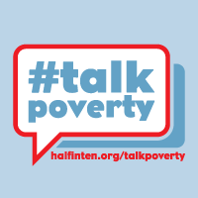 **Join the #TalkPoverty Online Movement**

#TalkPoverty is a network of social media activists who use Twitter, Facebook and other social platforms to share resources, and raise their voice online for low-income families through local and national actions.  Sign-up for the #TalkPoverty network today to receive news and updates geared toward online social media activists including:

- National action campaign opportunities  
- Social media training and resources  
- Opportunities to amplify your individual and organizational social media reach  
- Sample tweets, infographics, and other shareable resources

**Join the movement and raise your voice around the 50th anniversary of the War on Poverty!**

* **Sign-up to join the campaign** at: [halfinten.org/talkpoverty](http://www.halfinten.org/talkpoverty)
* **Like #Talkpoverty on facebook**: <http://www.facebook.com/TalkPoverty>
* **Follow Half in Ten on Twitter**: <http://www.twitter.com/halfinten>

Here are some sample tweets and facebook posts to get you started:

Refer to [State of the States 2013](http://www.americanprogress.org/issues/poverty/news/2013/12/17/81323/resetting-the-poverty-debate-state-of-the-states-2013/) to customize the following tweets about SNAP and UI

* [X%] of [state] homes are food insecure. Now is not the time to cut SNAP <http://bit.ly/1dkULje> [~~#~~SNAPworks](https://twitter.com/search?q=%23SNAPworks) [~~#~~talkpoverty](https://twitter.com/search?q=%23talkpoverty) via [~~@~~halfinten](https://twitter.com/halfinten)
* Ranked [insert rank], only [X%] of [state]’s unemployed received unemployment insurance. We must extend UI! [http://bit.ly/1dkULje](http://t.co/r46Deq5aCB) [~~#~~**StateofPoverty**](https://twitter.com/search?q=%23StateofPoverty&src=hash)

Refer to the charts at the end of this toolkit to customize the following tweets about SNAP and UI:

* [x] thousand unemployed people in [state] are losing access to unemployment benefits in 2014 unless they’re restored #renewUI #talkpoverty
* Hungry families in [state] have already lost [$] in SNAP benefits – no more cuts to nutrition assistance in Farm Bill! #SNAPworks
* How does your state rank? Check out State of the States to see your [~~#~~stateofpoverty](https://twitter.com/search?q=%23stateofpoverty) & opportunity <http://bit.ly/JZgKD9>  via [~~@~~HalfinTen](https://twitter.com/HalfinTen)
* The War on Poverty didnt fail us, our economy has failed us & the safety net is working overtime to keep up [~~#~~noSNAPcuts](https://twitter.com/search?q=%23noSNAPcuts) [~~#~~renewUI](https://twitter.com/search?q=%23renewUI)

**State-by-State Impact of Unemployment Insurance Cuts**

According to the Center on Budget Priorities, approximately [5 million Americans](http://www.cbpp.org/cms/index.cfm?fa=view&id=4060) are expected to lose emergency unemployment benefits over the next 12 months. Use these state-by-state impact numbers as your develop advocacy materials to urge Congress to restore these important benefits for families that are still struggling in an economy that’s failing them.

Table 1 shows the Department of Labor’s estimates of the number of people in each state that would be affected over the next 12 months if EUC is allowed to expire.  In 11 states, more than 100,000 people would lose access to benefits.

|  |  |  |  |
| --- | --- | --- | --- |
| **Table 1 People Losing Access to Emergency Unemployment Compensation  Through December 2014 if Program Expires as Scheduled** | | | |
| State | Unemployed losing access to benefits | State | Unemployed losing access to benefits |
| Alabama | 48,100 | Nebraska | 16,700 |
| Alaska | 23,300 | Nevada | 60,300 |
| Arizona | 67,000 | New Hampshire | 8,500 |
| Arkansas | 40,300 | New Jersey | 260,100 |
| California | 836,100 | New Mexico | 25,500 |
| Colorado | 72,800 | New York | 383,000 |
| Connecticut | 85,100 | North Carolina | 0* |
| Delaware | 13,800 | North Dakota | 7,900 |
| District of Columbia | 18,200 | Ohio | 128,600 |
| Florida | 260,400 | Oklahoma | 33,000 |
| Georgia | 164,700 | Oregon | 76,100 |
| Hawaii | 13,300 | Pennsylvania | 262,500 |
| Idaho | 20,300 | Puerto Rico | 80,200 |
| Illinois | 230,500 | Rhode Island | 21,700 |
| Indiana | 69,300 | South Carolina | 52,400 |
| Iowa | 35,500 | South Dakota | 1,600 |
| Kansas | 35,300 | Tennessee | 79,000 |
| Kentucky | 53,200 | Texas | 285,200 |
| Louisiana | 30,400 | Utah | 20,200 |
| Maine | 18,100 | Vermont | 5,100 |
| Maryland | 82,600 | Virgin Islands | 3,500 |
| Massachusetts | 141,000 | Virginia | 69,900 |
| Michigan | 189,700 | Washington | 94,100 |
| Minnesota | 65,500 | West Virginia | 24,700 |
| Mississippi | 37,600 | Wisconsin | 99,000 |
| Missouri | 84,500 | Wyoming | 6,700 |
| Montana | 14,300 |  |  |
| *Emergency Unemployment Compensation is not available in North Carolina because earlier this year, the state cut weekly UI benefit levels in violation of federal rules that require states that accept emergency federal benefits to maintain their benefit levels. Source: Department of Labor and Council of Economic Advisers | | | |

**State-by-State Impact of November 2013 Nutrition Assistance Cuts (SNAP/Food Stamps)**

While Congress contemplates making further deep cuts to nutrition assistance as part of the Farm Bill, recipients across the country are already dealing with the impacts of a benefit cut that happened this past November due to an expiration of funding made available under the American Recovery Act. According to the [Center on Budget and Policy Priorities](http://www.cbpp.org/cms/?fa=view&id=3899), this cut affected approximately 47 million Americans. Help us urge Congress not to make any further cuts to nutrition assistance in the Farm Bill by sharing these state-by-state impact numbers in your advocacy materials.

|  |  |  |  |
| --- | --- | --- | --- |
| **Table 2 The SNAP ARRA Termination: Estimated State-by-State Impact in Fiscal Year 2014** | | | |
|  | Total SNAP Benefit Cut to State (in millions of dollars, from November 2013  through September 2014) | Number of SNAP Recipients in FY 2014 (all of whom are impacted by the cut) | |
| Total | Share of Total State Population |
| Alabama | -$98 | 910,000 | 19% |
| Alaska | -$12 | 95,000 | 13% |
| Arizona | -$109 | 1,101,000 | 17% |
| Arkansas | -$52 | 501,000 | 17% |
| California | -$457 | 4,168,000 | 11% |
| Colorado | -$55 | 511,000 | 10% |
| Connecticut | -$44 | 424,000 | 12% |
| Delaware | -$16 | 154,000 | 17% |
| District of Columbia | -$15 | 144,000 | 22% |
| Florida | -$379 | 3,552,000 | 18% |
| Georgia | -$210 | 1,947,000 | 19% |
| Hawaii | -$33 | 190,000 | 13% |
| Idaho | -$24 | 230,000 | 14% |
| Illinois | -$220 | 2,031,000 | 16% |
| Indiana | -$98 | 925,000 | 14% |
| Iowa | -$43 | 421,000 | 13% |
| Kansas | -$33 | 317,000 | 11% |
| Kentucky | -$94 | 875,000 | 20% |
| Louisiana | -$98 | 920,000 | 20% |
| Maine | -$26 | 251,000 | 19% |
| Maryland | -$82 | 774,000 | 13% |
| Massachusetts | -$95 | 889,000 | 13% |
| Michigan | -$183 | 1,775,000 | 18% |
| Minnesota | -$55 | 556,000 | 10% |
| Mississippi | -$70 | 664,000 | 22% |
| Missouri | -$96 | 933,000 | 15% |
| Montana | -$13 | 131,000 | 13% |
| Nebraska | -$18 | 180,000 | 10% |
| Nevada | -$37 | 359,000 | 13% |
| New Hampshire | -$12 | 117,000 | 9% |
| New Jersey | -$90 | 873,000 | 10% |
| New Mexico | -$47 | 442,000 | 21% |
| New York | -$332 | 3,185,000 | 16% |
| North Carolina | -$166 | 1,708,000 | 17% |
| North Dakota | -$6 | 57,000 | 8% |
| Ohio | -$193 | 1,847,000 | 16% |
| Oklahoma | -$66 | 615,000 | 16% |
| Oregon | -$84 | 819,000 | 21% |
| Pennsylvania | -$183 | 1,779,000 | 14% |
| Rhode Island | -$20 | 181,000 | 17% |
| South Carolina | -$93 | 875,000 | 18% |
| South Dakota | -$11 | 104,000 | 12% |
| Tennessee | -$141 | 1,345,000 | 20% |
| Texas | -$411 | 3,997,000 | 15% |
| Utah | -$26 | 253,000 | 9% |
| Vermont | -$10 | 101,000 | 16% |
| Virginia | -$99 | 941,000 | 11% |
| Washington | -$114 | 1,113,000 | 16% |
| West Virginia | -$36 | 350,000 | 19% |
| Wisconsin | -$89 | 861,000 | 15% |
| Wyoming | -$4 | 39,000 | 7% |
| Guam | -$7 | 45,000 | N/A |
| Virgin Islands | -$4 | 27,000 | N/A |
| Puerto Rico Block Grant | $0 | N/A | N/A |
| Total | **-$5,000** | **47,600,000** | 15% |
| Source: CBPP estimates based on USDA’s June 2013 Thrifty Food Plan, CBO May 2013 baseline, 2011 USDA data on SNAP Household Characteristics, recent USDA administrative data on the number of SNAP participants, and U.S. Census Bureau data on state populations.  Notes: The number of SNAP recipients shown is for a typical, or average month in fiscal year 2014.  In addition to the cuts shown in this table, an additional $6 billion in cuts are expected to occur in fiscal years 2015 and 2016 under CBO’s May 2013 food inflation projections. | | | |

**Shareable Charts and Infographics**

**From Center for American Progress and Half in Ten:**

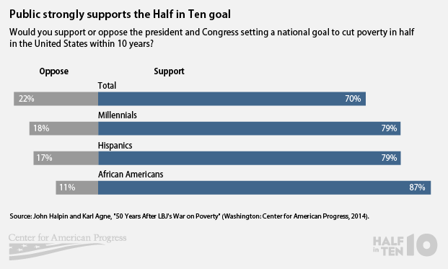

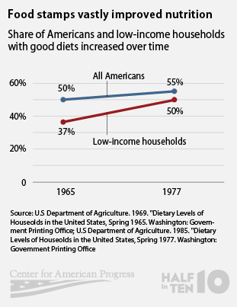 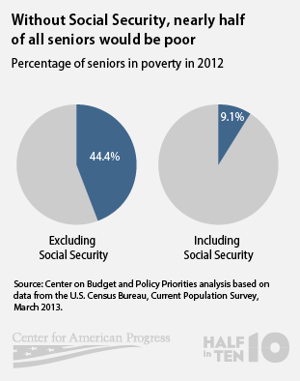

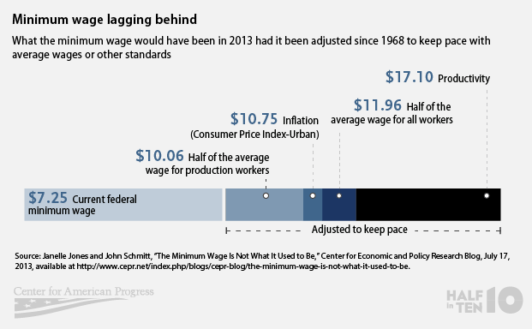

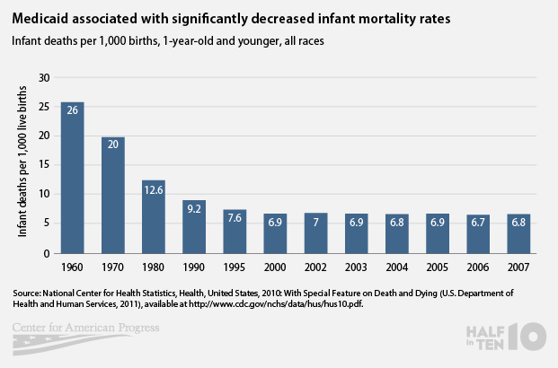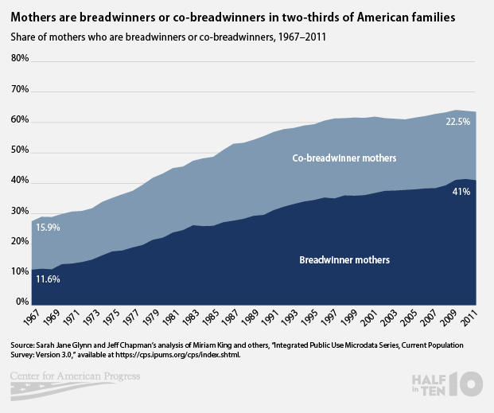

**From the Center on Budget and Policy Priorities:**

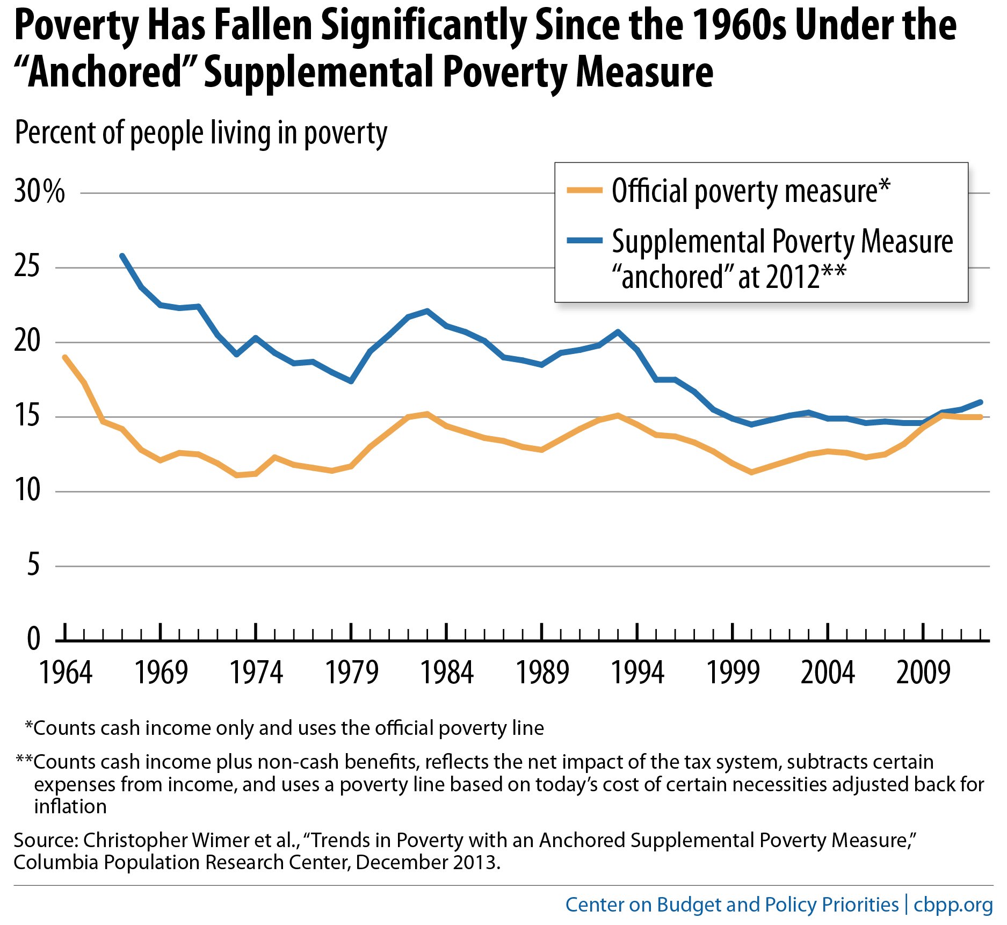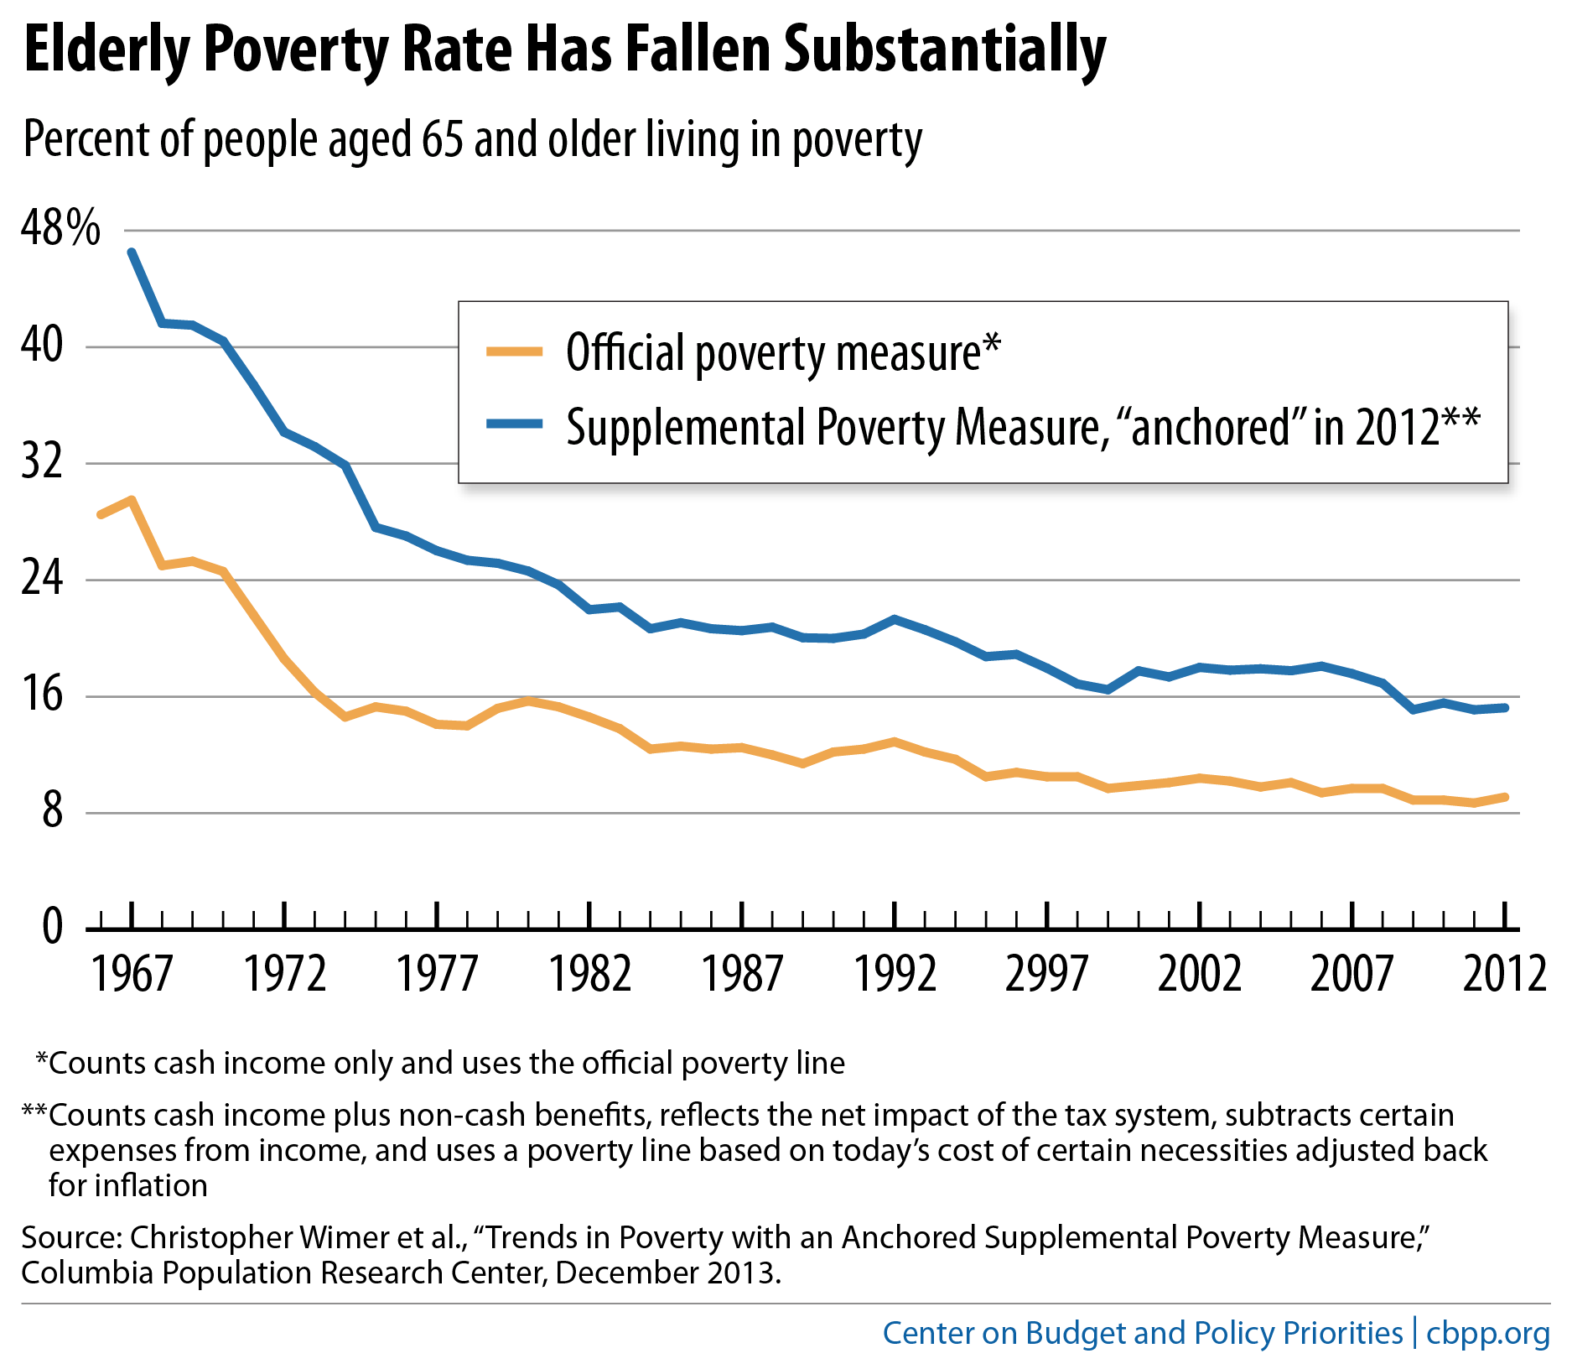

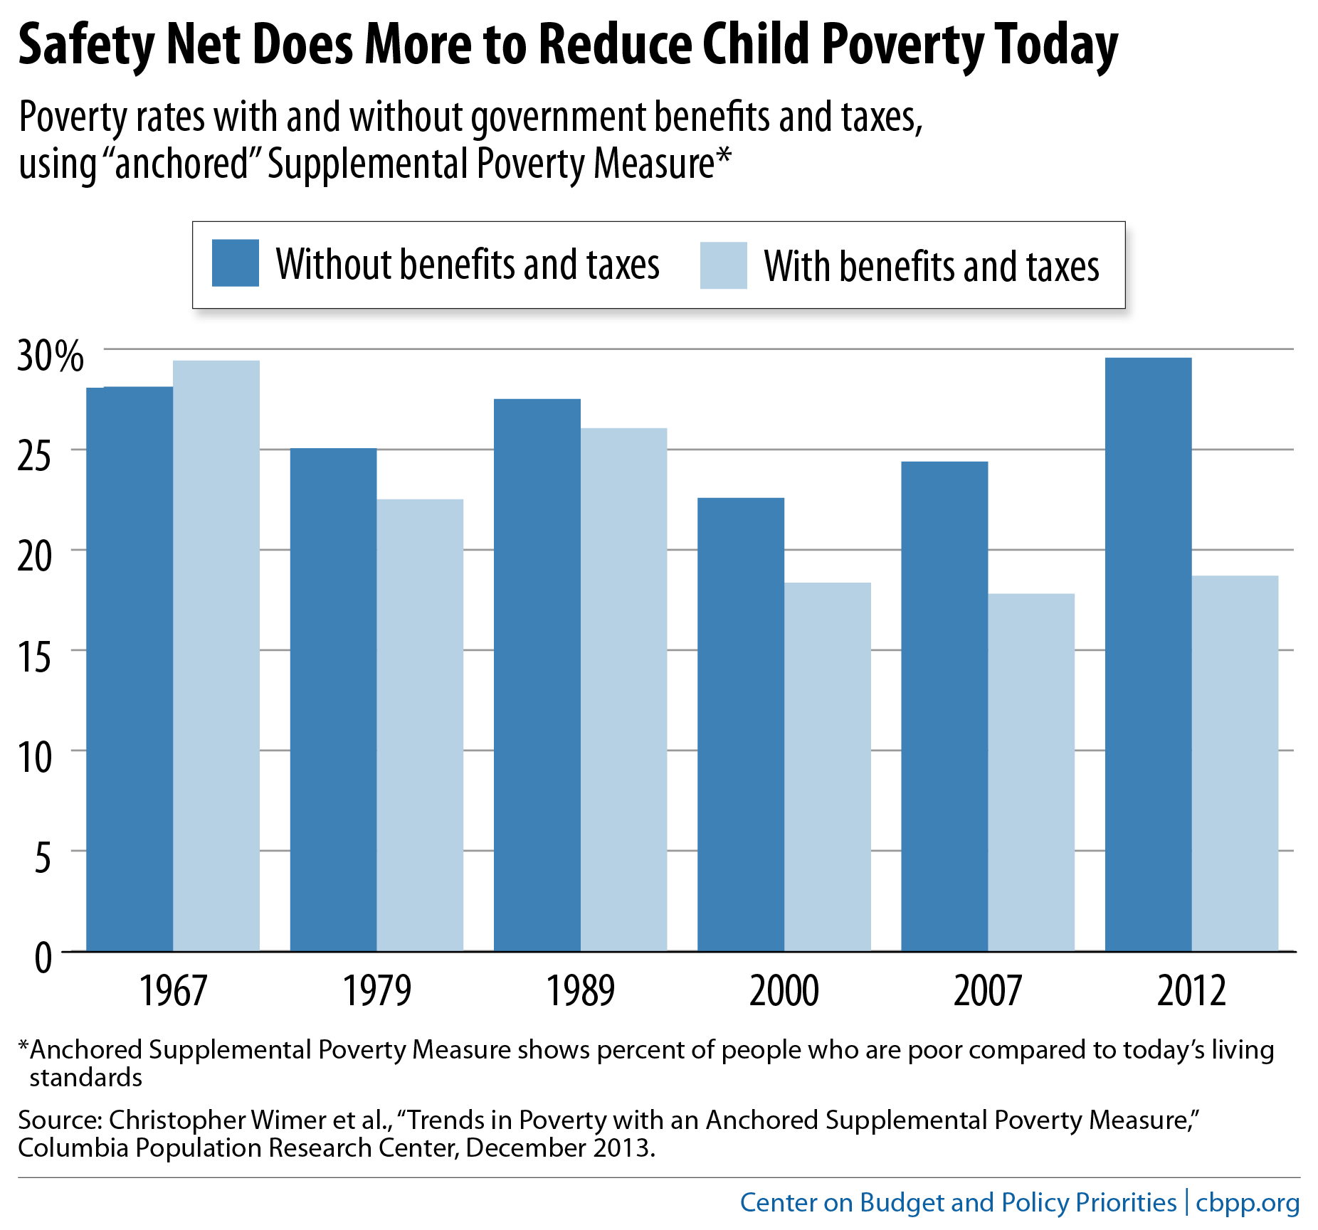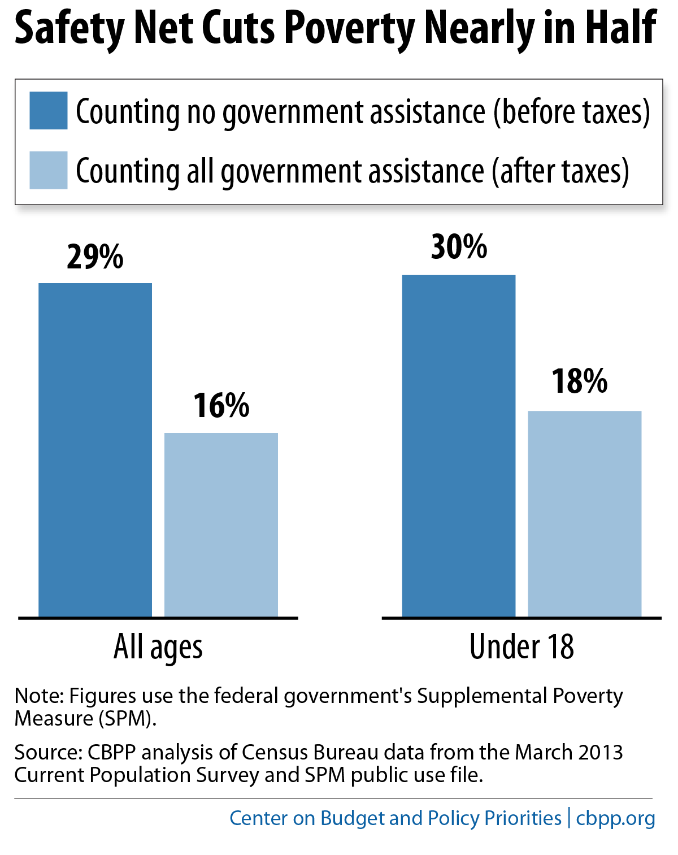

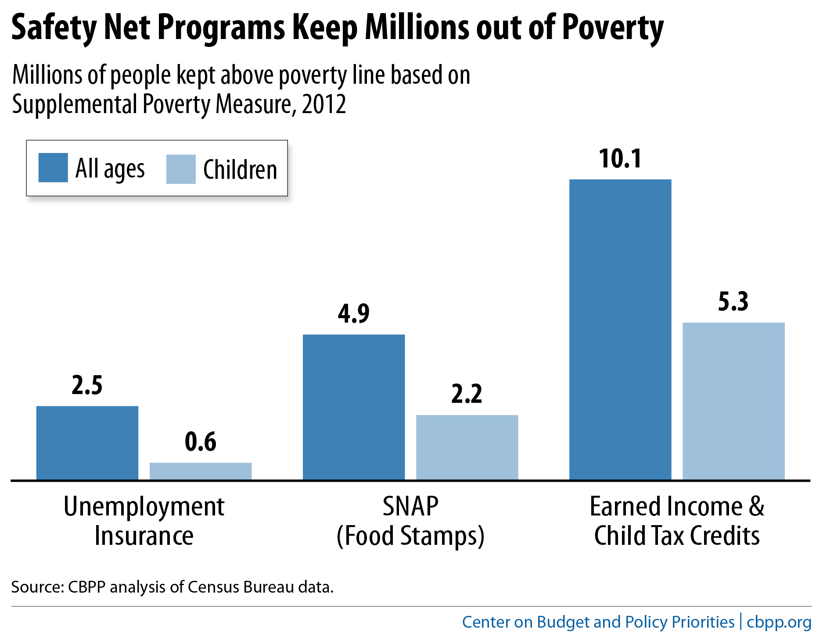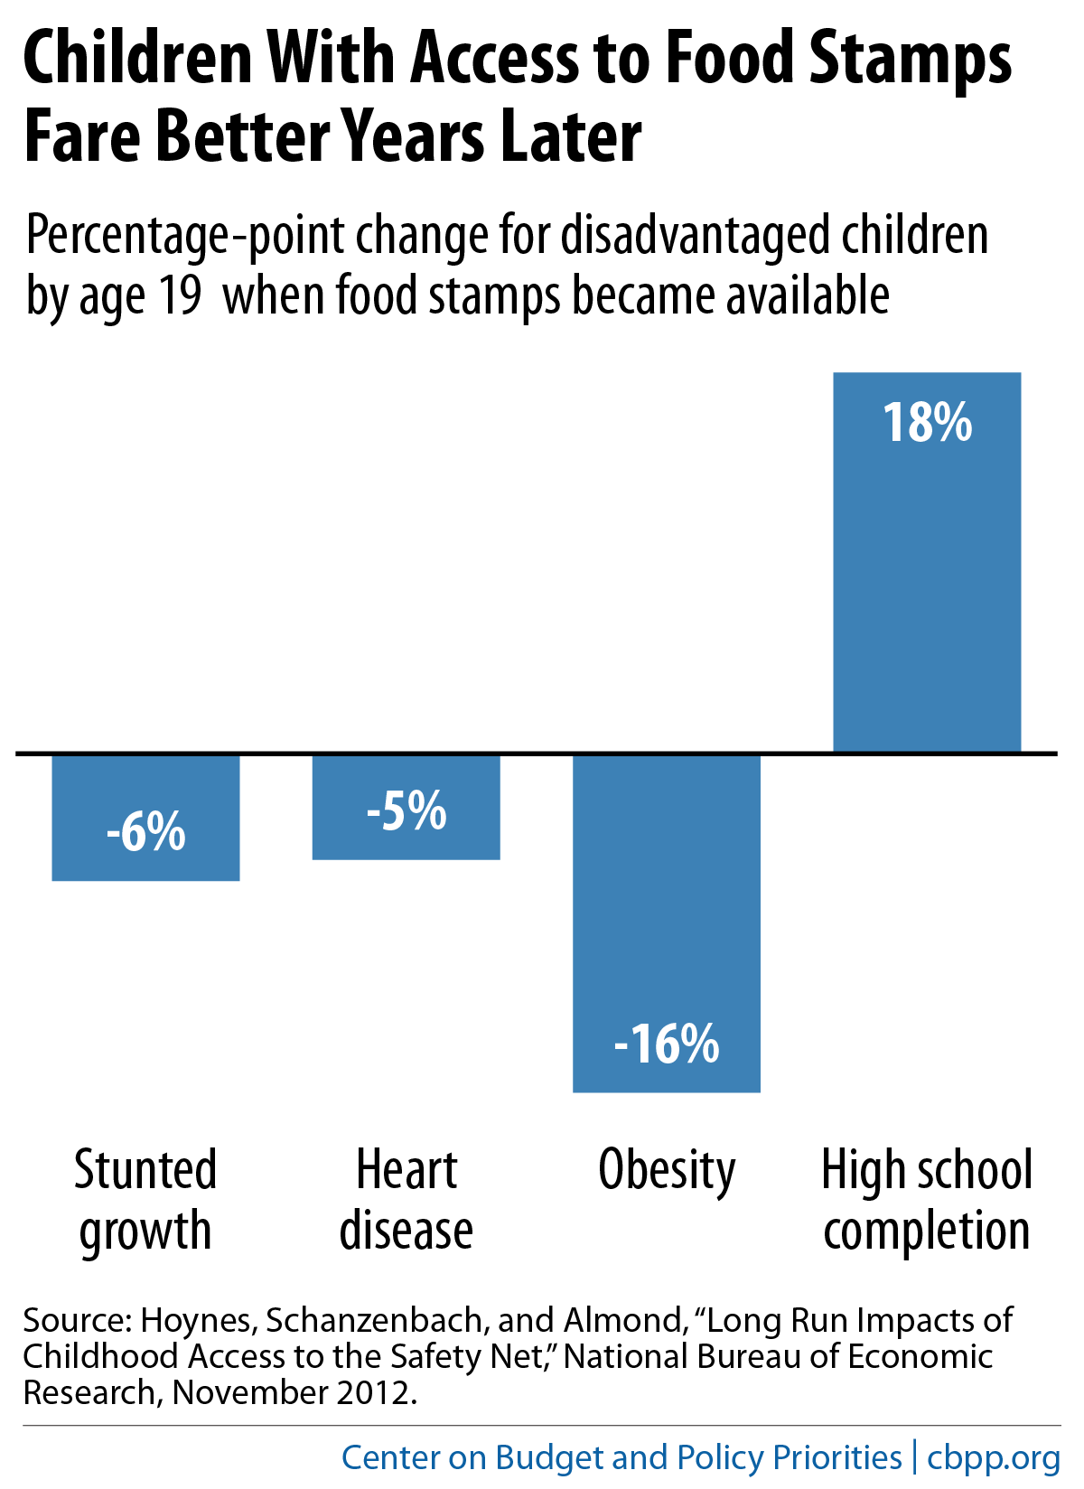

**Other Resources:**

[The War on Poverty Then and Now: Applying Lessons Learned to the Challenges and Opportunities Facing a 21st-Century America](http://www.americanprogress.org/issues/poverty/report/2014/01/07/81661/the-war-on-poverty-then-and-now/)

[50 Years After LBJ’s War on Poverty: A Study of American Attitudes About Work, Economic Opportunity, and the Social Safety Net](http://www.americanprogress.org/issues/poverty/report/2014/01/07/81702/50-years-after-lbjs-war-on-poverty/)

[Why Congress Must Extend Emergency Unemployment Benefits](http://www.americanprogress.org/issues/economy/news/2013/11/20/79726/why-congress-must-extend-emergency-unemployment-benefits/) (includes interactive map with each state’s unemployment situation)

[Food for Thought: New Poverty Data Underscore Effectiveness if Nutrition Assistance as Congress Considers Cuts to Food Aid](http://www.americanprogress.org/issues/poverty/news/2013/11/06/78980/food-for-thought-new-poverty-data-underscore-effectiveness-of-nutrition-assistance-as-congress-considers-cuts-to-food-aid/)

[Resetting the Poverty Debate: State of the States 2013](http://www.americanprogress.org/issues/poverty/news/2013/12/17/81323/resetting-the-poverty-debate-state-of-the-states-2013/)

[Resetting the Poverty Debate: Renewing Our Commitment to Shared Prosperity](http://www.americanprogress.org/issues/poverty/news/2013/10/29/78288/resetting-the-poverty-debate-renewing-our-commitment-to-shared-prosperity/)

[Infographic: Stop Slashing SNAP](http://www.americanprogress.org/issues/poverty/news/2013/09/16/74122/infographic-stop-slashing-snap/)

[30 years of Tackling Hunger on a Bipartisan Basis is in Danger of Failing](http://www.americanprogress.org/issues/poverty/news/2013/09/16/73551/30-years-of-tackling-hunger-on-a-bipartisan-basis-is-in-danger-of-failing-this-fall/)

[Stop Playing Politics With Hunger, an Op-Ed by Sens. Tom Daschle and Bob Dole](http://articles.latimes.com/2013/sep/16/opinion/la-oe-dole-daschle-food-stamps-20130916)

1.